Qazi Muhammad Bilal, Shahzadi Minahil Altaf, Umda Tu Nisa
Session: 2022 - 2026 | Department of software engineering
Mental Health Support Platform
Software Requirements Specification Document
17.12.2015

Revision History
Date | Description | Author | Comments
22 Dec 2025 | Version 1.0 | Qazi Muhammad Bilal, Shahzadi Minahil Altaf, Umda Tu Nisa | Updated functional requirements
02 Jan 2026 | Version 1.0 | Qazi Muhammad Bilal, Shahzadi Minahil Altaf, Umda Tu Nisa | Performance and security requirements refined
05 Jan 2026 | Version 1.0 | Qazi Muhammad Bilal, Shahzadi Minahil Altaf, Umda Tu Nisa | Final corrections and formatting

Document Approval
The following Software Requirements Specification has been accepted and approved by the following:
Signature | Printed Name | Title | Date
 | Dr. Muhammad Umar | Supervisor, CSSE 21306 | 06 Jan 2026

Table of Contents
1. Introduction 2
1.1 Purpose 2
1.2 Scope 2
1.3 Definitions, Acronyms, and Abbreviations 3
1.4 References 3
1.5 Overview 4
2. The Overall Description 6
2.1 Product Perspective 6
2.1.1 Operations 7
2.1.2 Site Adaptation Requirements 8
2.2 Product Functions 8
2.3 User Characteristics 9
2.4 General Constraints 10
2.5 Assumptions and Dependencies 11
3. Specific Requirements 13
3.1 External Interface Requirements 13
3.1.1 System Interfaces 13
3.1.2 Interfaces 14
3.1.3 Hardware Interfaces 15
3.1.4 Software Interfaces 15
3.1.5 Communications Interfaces 16
3.2 Functional Requirements 17
3.2.1 Feature 1: User Registration & Login System 17
3.2.2 Feature 2: Self-Assessment Quiz System 18
3.2.3 Feature 3: Mood Tracking System 18
3.2.4 Feature 4: AI-Assisted Emotional Support Chat 19
3.2.5 Feature 5: Appointment Booking System 20
3.2.6 Feature 6: Resource Library (Articles & Tips) 20
3.3 Use Cases 21
3.3.1 Use Case 1: User Login 21
3.3.2 Use Case 2: Complete Quiz 22
3.3.3 Use Case 3: Mood Logging 22
3.3.4 Use Case 4: AI Chat 22
3.3.5 Use Case 5: Appointment Booking 22
3.4 Classes / Objects 23
3.4.1 User Class 23
3.4.2 MoodLog Class 24
3.4.3 Quiz Class 24
3.4.4 Quiz Result Class 25
3.4.5 AIChat Class 26
3.4.6 Appointment Class 27
3.4.7 Therapist Class 27
3.4.8 Resource Class 28
3.5 Non-Functional Requirements 29
3.5.1 Performance 29
3.5.2 Reliability 29
3.5.3 Availability 30
3.5.4 Security 30
3.5.5 Maintainability 31
3.5.6 Portability 31
3.6 Inverse Requirements 31
3.7 Logical Database Requirements 32
3.7.1 Types of Information Stored 32
3.7.2 Frequency of Use 32
3.7.3 Access Requirements 32
3.7.4 Data Entities and Relationships (ER-level description) 33
3.7.5 Integrity Constraints 33
3.7.6 Data Retention Requirements 33
3.8 Design Constraints 33
3.8.1 Standards Compliance 33
4. Analysis Models 37
4.1 Sequence Diagrams 37
4.1.1 Sequence Diagram User Registration and Login 37
4.1.2 Sequence Diagram Mood Tracking and Analysis 38
4.1.3 Sequence Diagram AI Chat Interaction 38
4.1.4 Sequence Diagram Appointment Booking 39
4.2 Data Flow Diagrams (DFD) 39
4.2.1 DFD level 0 (Context Diagram) 39
4.2.2 DFD level 1 User management & mood tracking 40
4.2.3 DFD level 1 AI chat & appointment booking 40
4.3 State-Transition Diagrams (STD) 41
4.3.1 User Account State Transition 41
4.3.2 Mood Tracking State Transition 42
4.3.3 Appointment Booking State Transition 43
5. Supporting Information 45
Appendix A Background Research on: 45
Appendix A.1 Mental Health Support Systems 45
Appendix A.2 Artificial Intelligence in Mental Health 45
Appendix A.3 Mood Tracking and Behavioral Analytics 46
Appendix A.4 – Data Privacy and Security in Mental Health Systems 46
Appendix B Data Dictionary 46
Appendix B.1 User Data 46
Appendix B.2 MoodLog Data 47
Appendix B.3 Quiz Data 47
Appendix B.4 QuizResult Data 47
Appendix B.5 AIChat Data 48
Appendix B.6 Appointment Data 48

List of Figure
Figure 1 System Context Diagram 7
Figure 2Functional Relationship Summary 9
Figure 3 Data Entities and Relationships 33
Figure 4 User Registration and Login Sequence Diagram 37
Figure 5 Sequence Diagram Mood Tracking and Analysis 38
Figure 6 Sequence Diagram AI Chat Interaction 38
Figure 7 Sequence Diagram Appointment Booking 39
Figure 8 DFD level 0 (Context Diagram) 39
Figure 9 DFD level 1 User management & mood tracking 40
Figure 10 DFD level 1 AI chat & appointment booking 40
Figure 11 User Account State Transition Diagram 41
Figure 12 Mood Tracking State Transition Diagram 42
Figure 13 Appointment Booking State Transition Diagram 43

List of Table
Table 1 User Class Attribute 23
Table 2 User Class Functions 23
Table 3 MoodLog Class Attribute 24
Table 4 MoodLog Class Functions 24
Table 5 Quiz Class Attribute 25
Table 6 Quiz Class Functions 25
Table 7 Quiz Result Class Attribute 25
Table 8 Quiz Result Class Functions 26
Table 9 AIChat Class Attribute 26
Table 10 AIChat Class Functions 26
Table 11 Appointment Class Attribute 27
Table 12 Appointment Class Functions 27
Table 13 Therapist Class Attribute 27
Table 14 Therapist Class Functions 28
Table 15 Resource Class Attribute 28
Table 16 Resource Class Functions 28
Table 17 Appendix B.1 User Data 46
Table 18 Appendix B.2 MoodLog Data 47
Table 19 Appendix B.3 Quiz Data 47
Table 20 Appendix B.4 QuizResult Data 47
Table 21 Appendix B.5 AIChat Data 48
Table 22 Appendix B.6 Appointment Data 48

Chapter 1

1. Introduction
The Software Requirements Specification (SRS) document provides a complete description of the functional and non-functional requirements of the Mind Ease Mental Health Support System. This document explains what the system must do, ensuring that the designers and developers fully understand the systems expected behavior. This SRS focuses only on requirements, not design or implementation details.

1.1 Purpose
The purpose of this SRS is to clearly define the requirements of the Mind Ease Mental Health Support System, a web-based platform designed to support users in monitoring, improving, and understanding their mental health through personalized tools such as mood tracking, self-assessment quizzes, AI-assisted chat, and therapist appointment booking. This document is intended for:
- Developers and Designers: to understand system features and build the application accordingly.
- Project Supervisors and Evaluators: to review the project goals, scope, and planned functionalities.
- Testers: to verify that the final product meets all stated requirements.
- Stakeholders and End Users: to understand what the system will provide.

1.2 Scope
The software product to be developed is titled Mind Ease Mental Health Support System.
This system will:
- Provide users with self-assessment quizzes to evaluate stress, anxiety, or emotional states.
- Offer mood tracking features with visual insights and daily mood logs.
- Enable AI-assisted chat for basic emotional support and guidance.
- Allow users to book appointments with mental-health professionals.
- Maintain user profiles, login authentication, and secure data handling.
- Present educational resources, tips, and self-care content related to mental well-being.
This system will not:
- Replace certified psychologists or offer medical diagnosis.
- Provide emergency mental-health treatment.
- Function as a real-time crisis management platform.
Application and Benefits:
The system aims to:
- Help individuals better understand their emotional patterns.
- Provide an accessible, stigma-free environment for mental wellness.
- Offer AI-supported guidance for everyday emotional challenges.
- Connect users with professionals when deeper support is needed.
- Empower users through consistent tracking, reflection, and personalized insights.
The scope described here summarizes the overall objectives and benefits of the system without listing individual requirements, which are detailed in later sections.

1.3 Definitions, Acronyms, and Abbreviations
Below are the definitions and abbreviations used within this SRS:
- AI: Artificial Intelligence.
- API: Application Programming Interface.
- UI: User Interface.
- UX: User Experience.
- SRS: Software Requirements Specification
- DB: Database
- CRUD: Create, Read, Update, Delete operations
- User Mood Log: Daily mood entries stored in the system
- Self-Assessment Quiz: A questionnaire used to evaluate emotional well-being
- Dashboard: Main page showing user’s mood trends, recent activities, and suggestions
- Therapist Appointment: A scheduled consultation with a mental-health professional
- Frontend: Client-side interface built using React.js
- Backend: Server-side logic built using Node.js and Express.js
- MongoDB: Database used to store system data

1.4 References
The following resources were consulted during the preparation of this SRS:
- IEEE Software Requirements Specification Standards – IEEE Computer Society.
- React.js Official Documentation – Meta Platforms Inc.
- Node.js & Express.js Documentation OpenJS Foundation.
- MongoDB Documentation – MongoDB Inc.
- Academic articles and online resources related to mental health assessment tools
and digital wellness applications.
These references can be obtained from their official websites or institutional libraries.

1.5 Overview
This SRS is organized into several major sections to ensure clarity and structured
understanding:
Section 1: Introduction
Provides an overview of the system, its purpose, scope, and key terms.
Section 2: Overall Description
Describes users, system environment, product functions, constraints, assumptions
and dependencies.
Section 3: Specific Requirements
Provides detailed functional and non-functional requirements, including system
features, inputs, outputs, and behavior.
Section 4: Appendices
Includes supporting information such as definitions, diagrams, and reference
materials. Readers interested in how the system behaves should focus on Section 2, while developers
implementing the system should carefully review Section 3 for complete requirement details.

Chapter 2

2. The Overall Description
This section provides a general description of the Mind Ease Mental Health Support
System. It explains the background, environment, major functions, user characteristics,
constraints, and assumptions that influence the overall requirements of the system. The
purpose of this section is to help customers and stakeholders understand, in simple
language, what the system will do and the context in which it will operate.
Detailed technical requirements are presented later in Section 3.

2.1 Product Perspective
The Mind Ease Mental Health Support System is an independent and self-contained
web application. It is not part of a larger system; however, it interacts with external services
such as AI-based sentiment analysis APIs (e.g., OpenAI), email services, and optional
third-party appointment scheduling tools.
The system is designed to fill a growing need in the digital mental health sector by providing emotionally supportive tools, such as:
- Daily mood tracking
- Self-assessment quizzes
- AI-assisted chat for emotional support
- Therapist appointment booking
- Educational mental health resources
Comparison with Other Platforms
While existing mental health platforms (e.g., Better Help, Calm, Mood fit) offer individual
features such as therapy booking or meditation, Mind Ease stands out through its all-in-one
integrated platform, combining assessment tools, personalized mood insights, AI-assisted
conversation, and a smooth user experience focused on accessibility and comfort.
Unlike commercial systems, Mind Ease does not replace professional medical evaluation,
but supports users in tracking and understanding their emotional trends.

System Context Diagram

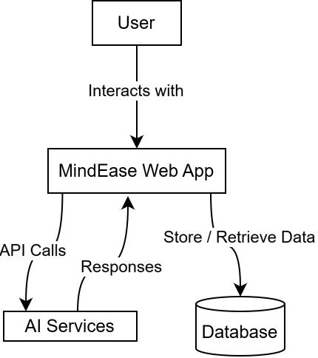
Figure 1 System Context Diagram
The web application will act as a black box, receiving user inputs and providing emotional
support outputs without exposing internal implementation details.

2.1.1 Operations
This subsection explains the normal and special operational conditions of the system:
- Modes of Operation:
- Interactive Mode: When users log in, complete quizzes, chat with AI, track
moods, and book appointments.
- Unattended Mode: When the system stores logs, generates mood insights,
and updates data automatically in the background.
- User Activity Periods:
- Most operations are user-driven and occur during interactive usage.
- Some automated tasks (such as daily mood reminders or data backups) may
occur without user interaction.
- Data Processing Support:
- The system will process quiz results, analyze mood logs, and store user data
securely using backend APIs and a database.
- AI-service calls will process text to analyze mood trends and provide
emotional support messages.
- Backup & Recovery Operations:
- Database backup schedules may be set (daily/weekly) to ensure data
integrity.
- Automatic recovery handling ensures system continuity even after
unexpected failures.
These operations ensure smooth system behavior and influence backend design choices.

2.1.2 Site Adaptation Requirements
Since the Mind Ease system is fully web-based, the site adaptation requirements are
minimal.
Key requirements include:
- Initialization Dependencies:
- A stable internet connection at the user’s location.
- Proper environment setup on server side (Node.js, database access,
environment variables).
- Required API keys for external AI-based services (e.g., OpenAI).
- Software Setup Needs:
- The backend must be deployed on a secure hosting server.
- A MongoDB database instance must be configured before system activation.
- Environment variables (API keys, DB URI, server port) must be set correctly.
There are no special hardware installation requirements such as generators or cooling
systems because Mind Ease is not installed physically at a customer site; it operates
completely online.

2.2 Product Functions
The Mind Ease Mental Health Support System performs several major functions that
support user mental well-being:
- User Registration & Login
- Users create accounts and authenticate securely.
- Self-Assessment Quizzes
- Stress, anxiety, and mood quizzes help users identify emotional states.
- Mood Tracking
- Users record daily moods which are later visualized using graphs/trends.
- AI-Assisted Emotional Support Chat
- AI-based chat provides personalized wellness messages and helpful
responses.
- Appointment Booking
- Users view therapist profiles and schedule online appointments.
- Dashboard with Insights
- Displays suggested resources, weekly mood summary, recent activity, and
recommendations.
- Educational Resources
- Articles, self-help guides, breathing exercises, and mental health tips.
These functions work together to create a supportive, user-friendly mental wellness platform.
Functional Relationship Summary
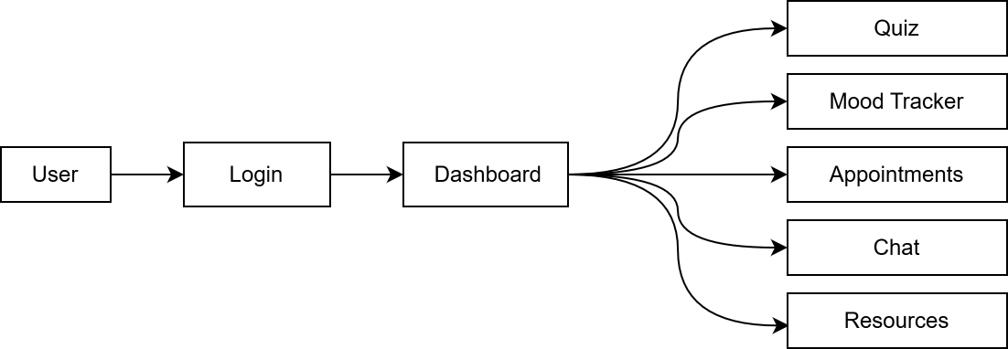
Figure 2Functional Relationship Summary

2.3 User Characteristics
The intended users of the Mind Ease system include:
- General Public
- Individuals aged 16 and above.
- People seeking emotional support or wanting to track their mood.
- Users may not be highly technical, so UI must be simple and intuitive.
- Students & Young Adults
- Typically familiar with mobile/web platforms.
- Need quick, accessible tools to manage stress and academic pressure.
- Therapists/Professionals (optional)
- Require an easy interface for managing bookings.
Design Considerations Based on Users
- The UI must be simple, calm, and minimalistic to avoid overwhelming users.
- Text should be clear and non-technical.
- Color choices must be soothing to create a positive emotional environment.
- Navigation must be intuitive for users with basic computer skills.

2.4 General Constraints
Several constraints influence the design and development of the Mind Ease system:
- Regulatory Policies:
- The system must respect user privacy and ethical guidelines (e.g., user
consent, data protection).
- Hardware Limitations:
- None for end users; any device with a browser is sufficient.
- External Interfaces:
- AI and email APIs must be accessible.
- Database must maintain stable connections.
- Parallel Operation:
- Multiple users may use the system simultaneously; concurrency must be
handled.
- Audit Functions:
- Logs for user activity and system operations should be maintained.
- Security Requirements:
- Data encryption, secure authentication, and restricted API access.
- Reliability:
- System should be available with minimal downtime.
- Criticality:
- Not a medical emergency system → must clearly state this to users.
These constraints help determine limits and mandatory considerations in the system.

2.5 Assumptions and Dependencies
The system relies on certain assumptions and external conditions:
- Users have internet access and a functional device.
- The hosting server supports Node.js and MongoDB.
- External AI API services remain available and stable.
- Browsers support modern web standards (JavaScript, HTML5).
- Therapists who join the platform manage their availability schedules.
- Users provide accurate information during assessments.
- Email or SMS service for notifications remains active.
If any of these assumptions change, the SRS may need to be updated accordingly.

Chapter 3

3. Specific Requirements
This section describes the detailed functional and non-functional requirements of the
Mind Ease Mental Health Support System. Each requirement is uniquely identified,
testable, traceable, and written at a level that can guide developers during system design,
implementation, and testing.
This section does not describe how the system will be designed; it describes what the
system must do

3.1 External Interface Requirements

3.1.1 System Interfaces
The system interacts with several external services and components. Each interface is listed
below along with its purpose and expected behavior.

3.1.1.1 AI Sentiment Analysis API
- Description:
The system must integrate with an AI API (e.g., OpenAI API) to perform text-based
sentiment analysis for the AI chat and mood prediction feature.
- Functionality:
Sends user-provided text and receives analyzed sentiment or AI-generated
supportive messages.
- Interface:
HTTPS-based REST API
Request Format: JSON
Response Format: JSON
- Purpose:
To provide personalized and adaptive emotional support.

3.1.1.2 Email/Notification Service
- Description:
The system must connect with a mail service (e.g., Node mailer with SMTP) to send
appointment confirmations and password reset emails.
- Interface:
SMTP / Secure Email API
- Purpose:
Notify users about appointments, account activities, and reminders.

3.1.1.3 Database System (MongoDB)
- Description:
The system must store user data, quiz results, mood entries, chat logs, and
appointment bookings in MongoDB.
- Interface:
Connection via Mongoose library (MongoDB driver).
- Purpose:
Provide persistent, secure, and scalable data management.

3.1.2 Interfaces

3.1.2.1 Logical Interface Characteristics
The system will be accessed through a web-based Graphical User Interface (GUI)
developed using React.js.
Key characteristics include:
- Intuitive navigation with a top Navbar and left-side Dashboard panel.
- Simple, calming color theme suitable for mental health applications.
- Large buttons and readable typography for accessibility.
- Interactive visual elements (charts, progress bars, cards).

3.1.2.2 Interface Optimization for Users
The interface must:
- Support both desktop and mobile devices (responsive design).
- Present accurate error messages (invalid inputs, blank fields).
- Include focus indicators for screen-reader compatibility.
- Support accessible color contrast for users with visual impairment.
- Use clear and friendly microcopy (“How are you feeling today?” instead of technical language).

3.1.2.3 Interaction Modes
- Users interact with forms, quizzes, charts, and chat windows.
- All interactions occur through point-and-click and keyboard navigation.
- No command-line interface is required.

3.1.3 Hardware Interfaces
The system has no direct hardware interface requirements.
Since Mind Ease is a web-based software application, it does not communicate with or
control any specialized hardware devices.
The only requirement is that users access the system through standard computing devices
(desktop, laptop, tablet, smartphone) with an internet connection.

3.1.4 Software Interfaces
The system depends on several external software products and APIs to operate correctly.

3.1.4.1 Node.js
- Mnemonic: Node
- Version: LTS (16.x or later)
- Source: OpenJS Foundation
- Purpose: Backend server runtime environment.

3.1.4.2 Express.js
- Mnemonic: Express
- Version: Compatible with Node.js
- Purpose: Provides routing and middleware support for API endpoints.

3.1.4.3 MongoDB + Mongoose
- Mnemonic: MongoDB
- Version: 5.0+
- Source: MongoDB Inc.
- Purpose: Database to store all system data.
- Interface: JSON-based documents through Mongoose ORM.

3.1.4.4 React.js
- Mnemonic: React
- Version: 18+
- Source: Meta Platforms
- Purpose: Frontend UI rendering and component management.

3.1.4.5 AI Sentiment/Chat API
- Mnemonic: OpenAI API / Similar
- Protocol: HTTPS REST API
- Purpose: AI-driven emotional support, mood prediction, and message generation.
- Message Format:
  - Request: JSON containing user text
  - Response: JSON containing sentiment or response text.

3.1.4.6 Chart Library (e.g., Chart.js or Recharts)
- Purpose: Display mood trends and insights in visual form.

3.1.4.7 CSS Framework (Tailwind / Custom CSS)
- Purpose: Provide consistent design and responsive layouts.

3.1.5 Communications Interfaces
The system relies on standard communication protocols:
- HTTP/HTTPS Protocol
- All requests between frontend, backend, and APIs occur through secure
HTTPS.
- REST-based architecture.
- TCP/IP
- Required at networking level for all client-server communication.
- SMTP (Email Service)
- Used for account notifications and reminders.
- WebSockets (Optional)
- If real-time chat is added in future updates, WebSockets may be used.
- Not required in the first version.
Since the system relies on widely used standard web protocols, no custom communication
protocol is needed.

3.2 Functional Requirements
This section defines the core functional requirements of the Mind Ease Mental Health Support System. Each feature is described in detail, including its inputs, internal processing, outputs, and error handling mechanisms.

3.2.1 Feature 1: User Registration & Login System
Introduction
This feature allows users to create accounts, log in securely, and access personalized
features such as quizzes, chat, and mood tracking.
Inputs
- Full Name
- Email Address
- Password
- Optional Profile Data
Processing
- Validate inputs (correct format, non-empty fields).
- Check if email already exists.
- Hash password before storing.
- Authenticate user by verifying email + hashed password.
- Generate secure session token or JWT.
Outputs
- Successful registration confirmation.
- Successful login → redirect to Dashboard.
- Session token for authenticated access.
Error Handling
- “Email already exists.”
- “Invalid email or password.”
- Missing required fields.
- Server/database connection error.

3.2.2 Feature 2: Self-Assessment Quiz System
Introduction
This feature allows users to complete mental health self-assessment quizzes (stress,
anxiety, mood level).
Inputs
- Selected quiz type
- User answers for each question
- User ID
Processing
- Retrieve quiz questions.
- Record selected answers.
- Calculate score based on predefined scoring rules.
- Categorize score (Low / Moderate / High).
Outputs
- Score summary
- Stress/anxiety level category
- Suggested recommendations (tips, resources, or chat option)
Error Handling
- Missing answer for a required question
- Failed to load quiz
- Score calculation error
- Database failure when saving results

3.2.3 Feature 3: Mood Tracking System
Introduction
Allows users to record daily moods and view emotional trends.
Inputs
- Selected mood (emoji, scale, or category)
- Date
- Optional note
Processing
- Validate mood input.
- Store entry in user’s profile.
- Update weekly/monthly analytics.
- Generate trend graph data.
Outputs
- Mood log stored.
- Visual trend chart.
- Daily/weekly insights.
Error Handling
- Duplicate entry for same day.
- Invalid mood type.
- Failed to save mood entry.

3.2.4 Feature 4: AI-Assisted Emotional Support Chat
Introduction
This feature enables users to chat with an AI assistant that provides supportive, empathetic responses.
Inputs
- User message text
- User ID
Processing
- Validate text input.
- Send message to AI sentiment/response API.
- Receive generated supportive reply.
- Store messages in chat history.
Outputs
- AI-generated response
- Updated chat window
- Conversation history
Error Handling
- Empty message
- API request timeout
- Invalid API key
- Failed to load chat history

3.2.5 Feature 5: Appointment Booking System
Introduction
Allows users to browse therapists and book counseling appointments.
Inputs
- Selected therapist
- Date & Time
- User ID
Processing
- Check therapist availability.
- Validate date/time format.
- Save appointment to database.
- Send confirmation email.
Outputs
- Appointment confirmation message
- Email notification
- Appointment listed in user’s dashboard
Error Handling
- Therapist unavailable
- Invalid date/time
- Failed to save appointment
- Email sending failure

3.2.6 Feature 6: Resource Library (Articles & Tips)
Introduction
Provides users with access to mental health resources.
Inputs
User selects a category or article
Processing
- Retrieve and display relevant resources.
- Track user interactions (optional).
Outputs
- Display of article/content
- List of suggested readings
Error Handling
- Resource not found
- Failed API/database request

3.3 Use Cases
This section describes the major use cases of the Mind Ease system.
Each use case represents a key functional interaction between the user and the application.
The purpose of these use cases is to define how different types of users (Admin, Family Member) will achieve their goals within the system.

3.3.1 Use Case 1: User Login
Primary Actor: Registered User
Precondition: User account exists
Main Flow:
- User enters email and password.
- System validates credentials.
- System logs user in.
- Dashboard appears.
Postcondition: User authenticated.
Alternate Flows:
- Wrong password entered → error message.
- Account does not exist → suggest signup.

3.3.2 Use Case 2: Complete Quiz
Primary Actor: Registered User
Main Flow:
- User selects quiz.
- System loads questions.
- User submits answers.
- System calculates result.
- System shows score + recommendations.
Postcondition: Result stored.

3.3.3 Use Case 3: Mood Logging
Primary Actor: Registered User
Main Flow:
- User selects mood.
- System saves mood entry.
- System updates trend chart.
Postcondition: Daily mood stored.

3.3.4 Use Case 4: AI Chat
Primary Actor: User
Main Flow:
- User types message.
- System sends message to AI API.
- AI sends supportive reply.
- Conversation displayed.

3.3.5 Use Case 5: Appointment Booking
Primary Actor: User
Main Flow:
- User selects therapist.
- User chooses available date/time.
- System confirms booking.
- Confirmation email sent.

3.4 Classes / Objects
This section describes the major classes/objects of the Mind Ease Mental Health Support System.
Each class represents a real-world entity of the system and is directly traceable to the functional requirements and use cases defined in Section 3.2 and 3.3.3.4.1

3.4.1 User Class
Attribute
Table 1 User Class Attribute
Attribute | Description
userId | Unique identifier for each user
Name | Full name of the user
Email | User email address (unique)
Password | Encrypted user password
Role | User role (user / admin / therapist)
Age | Age of the user
Gender | Gender of the user
createdAt | Account creation date
lastLogin | Last login timestamp

Functions
Table 2 User Class Functions
Function Name | Description
register() | Registers a new user
login() | Authenticates user
logout() | Ends user session
updateProfile() | Updates user profile data
deleteAccount() | Deletes user account

Reference:
Functional Requirements: 3.2.1
Use Cases: User Registration, User Login

3.4.2 MoodLog Class
Attribute
Table 3 MoodLog Class Attribute
Attribute | Description
moodId | Unique mood record ID
userId | Reference to User
moodType | Selected mood (happy, sad, anxious, etc.)
Intensity | Mood intensity level (1–10)
Note | Optional user note
Date | Date of mood entry

Functions
Table 4 MoodLog Class Functions
Function Name | Description
addMood() | Adds daily mood entry
updateMood() | Updates mood data
deleteMood() | Removes mood entry
getMoodHistory() | Retrieves mood history
analyzeMood() | Sends data for AI analysis

Reference:
Functional Requirements: 3.2.2
Use Cases: Mood Tracking

3.4.3 Quiz Class
Attribute
Table 5 Quiz Class Attribute
Attribute | Description
quizId | Unique quiz ID
title | Quiz title
description | Quiz purpose
totalQuestions | Number of questions
createdAt | Quiz creation date

Functions
Table 6 Quiz Class Functions
Function Name | Description
loadQuiz() | Loads quiz questions
submitQuiz() | Submits quiz answers
calculateScore() | Calculates quiz score
generateResult() | Generates mental health feedback

Reference:
Functional Requirements: 3.2.3
Use Cases: Mental Health Quiz

3.4.4 Quiz Result Class
Attribute
Table 7 Quiz Result Class Attribute
Attribute | Description
resultId | Unique result ID
userId | Reference to User
quizId | Reference to Quiz
score | Quiz score
interpretation | Result interpretation
date | Date of submission

Functions
Table 8 Quiz Result Class Functions
Function Name | Description
saveResult() | Stores quiz result
viewResult() | Displays quiz result
getHistory() | Retrieves result history

Reference:
Functional Requirements: 3.2.3

3.4.5 AIChat Class
Attribute
Table 9 AIChat Class Attribute
Attribute | Description
chatId | Unique chat session ID
userId | Reference to User
message | User message
response | AI-generated response
timestamp | Message time

Functions
Table 10 AIChat Class Functions
Function Name | Description
sendMessage() | Sends message to AI
receiveResponse() | Receives AI reply
saveChat() | Stores chat history
fetchHistory() | Retrieves chat history

Reference:
Functional Requirements: 3.2.4
Use Cases: AI Mental Health Chat

3.4.6 Appointment Class
Attribute
Table 11 Appointment Class Attribute
Attribute | Description
appointmentId | Unique appointment ID
userId | Reference to User
therapistId | Reference to Therapist
date | Appointment date
time | Appointment time
status | Booked / Cancelled / Completed

Functions
Table 12 Appointment Class Functions
Function Name | Description
bookAppointment() | Books an appointment
cancelAppointment() | Cancels appointment
rescheduleAppointment() | Reschedules booking
viewAppointments() | Displays appointments

Reference:
Functional Requirements: 3.2.5
Use Cases: Appointment Booking

3.4.7 Therapist Class
Attribute
Table 13 Therapist Class Attribute
Attribute | Description
therapistId | Unique therapist ID
name | Therapist name
specialization | Area of expertise
availability | Available time slots
contactInfo | Contact details

Functions
Table 14 Therapist Class Functions
Function Name | Description
viewSchedule() | Views appointment schedule
updateAvailability() | Updates availability
manageAppointments() | Handles appointments

Reference:
Functional Requirements: 3.2.5

3.4.8 Resource Class
Attribute
Table 15 Resource Class Attribute
Attribute | Description
resourceId | Unique resource ID
title | Resource title
type | Article / Video / Tip
description | Resource details
createdAt | Creation date

Functions
Table 16 Resource Class Functions
Function Name | Description
addResource() | Adds new resource
updateResource() | Updates resource
deleteResource() | Deletes resource
viewResources() | Displays resources

Reference:
Functional Requirements: 3.2.6
Use Cases: Self-Help Resources

3.5 Non-Functional Requirements
Non-functional requirements define the quality attributes of the Mind Ease Mental Health
Support System.
All requirements in this section are measurable, testable, and apply system-wide

3.5.1 Performance
- System Response Time
- 95% of all user requests (login, quiz loading, mood entry, chat response) shall
be processed within 1 second.
- AI chat responses shall be received within 3 seconds under normal load.
- Server Processing Speed
- Backend API endpoints must complete processing within 500ms for standard
operations.
- Page Load Time
- All UI pages should load within 2 seconds over a standard broadband
connection.
- Scalability
- The system must support a minimum of 500 concurrent users without
performance degradation.

3.5.2 Reliability
- Uptime Target
- The system shall maintain a reliability level of 99% uptime excluding
scheduled maintenance.
- MTBF (Mean Time Between Failures)
- The system shall maintain a minimum MTBF of 30 days.
- Fault Recovery
- The system must recover from non-critical failures within 2 minutes.
- Automatic reconnection to the database must occur if the connection is lost
temporarily.

3.5.3 Availability
- Availability Percentage
- System availability must be at least 99% over a 24-hour cycle.
- Downtime Window
- Downtime shall not exceed 1 minute per day for automated deployments or
background tasks.
- User Data Access
- Users should be able to access their dashboard and personal data at all times
except during scheduled maintenance.

3.5.4 Security
- Authentication & Authorization
- All secure operations require JWT-based authentication.
- Passwords must be hashed using industry-standard hashing algorithms (bcrypt or better).
- Data Encryption
- All communication between frontend, backend, and external APIs must use
- HTTPS (TLS 1.2 or higher).
- Sensitive data stored in the database must use encryption at rest.
- Access Control
- Only authorized users may access personal data, chat history, or
appointments.
- Admin users shall have restricted admin-panel access.
- Data Privacy
- No user mental health data shall be shared without explicit user consent.
- System must comply with basic digital privacy principles.
- Input Validation
- All user inputs must be validated to prevent SQL injection, XSS, CSRF, and other attacks.

3.5.5 Maintainability
- Code Modularity
- The system shall be developed using modular components to support
updates with minimal changes.
- Documentation
- Every major function must include internal comments and documentation.
- Error Logs
- The system must maintain a structured error log for debugging and maintenance.
- Dependency Updates
- All third-party libraries must be updated at least once every 6 months.

3.5.6 Portability
- Browser Compatibility
- The system must support modern browsers: Chrome, Firefox, Edge, Safari.
- Multi-Device Support
- The application must be fully responsive and accessible on mobile, tablet,
and desktop.
- Operating Systems
- As a web application, Mind Ease should function on Windows, macOS, Linux,
Android, and iOS.
- Deployment Flexibility
- The backend must be deployable on any cloud platform (AWS, Vercel,
Render, Digital Ocean).

3.6 Inverse Requirements
Inverse requirements describe what the system must NOT do (useful for clarity):
- The system shall not provide medical diagnosis or replace professional mental
health treatment.
- The system shall not offer emergency or crisis management services.
- The system shall not share user data with third parties without explicit consent.
- The system shall not allow unauthorized users to access personal data or chat
history.
- The system shall not store passwords in plain text.

3.7 Logical Database Requirements
The Mind Ease system requires structured data storage for users, quizzes, moods, chat
messages, appointments, and resources.

3.7.1 Types of Information Stored
- User data (name, email, password, profile info)
- Quiz definitions and questions
- Quiz results
- Mood logs
- Chat messages
- Therapist information
- Appointments and schedules
- Resource articles and metadata

3.7.2 Frequency of Use
- User login data → Daily
- Mood logs → Daily
- Quiz results → Weekly or as required
- Chat logs → Frequent
- Appointments → On demand
- Resources → Occasional

3.7.3 Access Requirements
- Users must only access their own data.
- Admins may access therapist profiles and resources.
- System should support read/write/delete operations (CRUD).

3.7.4 Data Entities and Relationships (ER-level description)

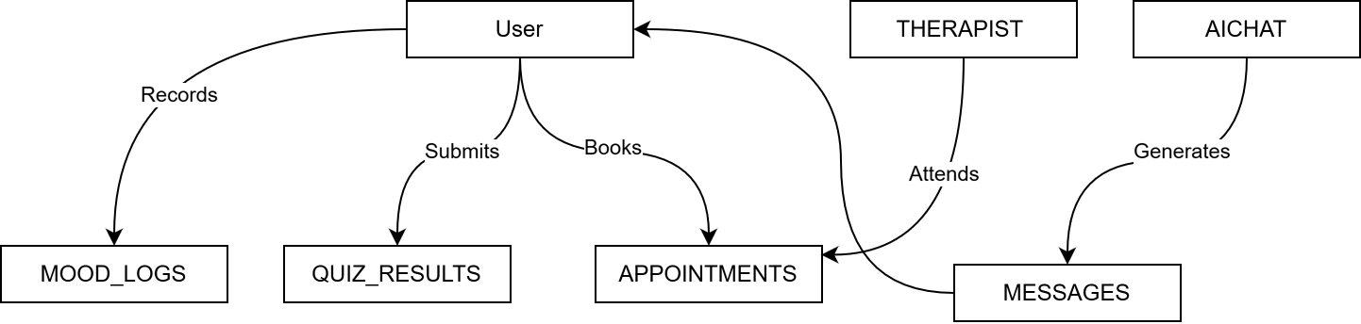
Figure 3 Data Entities and Relationships

3.7.5 Integrity Constraints
- Unique email constraint for all users.
- Appointment time must be unique per therapist slot.
- Mood log must not be duplicated for same user & date.
- Quiz results must include valid score and quiz ID.

3.7.6 Data Retention Requirements
- User data retained until account deletion.
- Mood logs retained for at least 1 year.
- Chat messages retained for 6 months for user history.
- Appointment logs retained for compliance for 1 year.

3.8 Design Constraints
Design constraints refer to limitations or requirements that influence the development,
deployment, and operation of the MediMate system.

3.8.1 Standards Compliance
The MindEase system must comply with the following standards:
- Data Format Standards
- JSON-based REST API must be used for all data exchange.
- Naming Conventions
- Database table/collection names must follow meaningful camelCase or
snake_case conventions.
- Consistent naming for UI components and API routes.
- Audit Tracing
- All updates to user data, bookings, or quiz results must be logged with
timestamps.
- Regulatory Considerations
- Must follow digital privacy principles similar to GDPR (where applicable).
- User consent required before collecting personal data.
- UI/UX Standards
- Accessible color contrast ratio (minimum 4.5:1).
- Include ALT text for images.
- Follow minimum WCAG accessibility recommendations.

Chapter 4

4. Analysis Models
This section presents the analysis models used to understand, refine, and validate the
system requirements described in Section 3 of the SRS.
Each model provides a visual or narrative representation of how the system behaves,
processes data, and responds to user interactions.
These models help developers, testers, and stakeholders clearly understand system
behavior before the design phase begins.

4.1 Sequence Diagrams

4.1.1 Sequence Diagram User Registration and Login
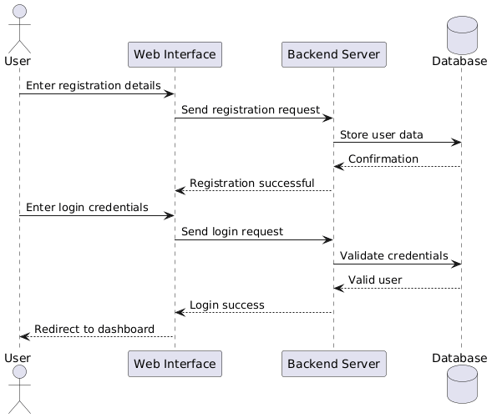
Figure 4 User Registration and Login Sequence Diagram

4.1.2 Sequence Diagram Mood Tracking and Analysis

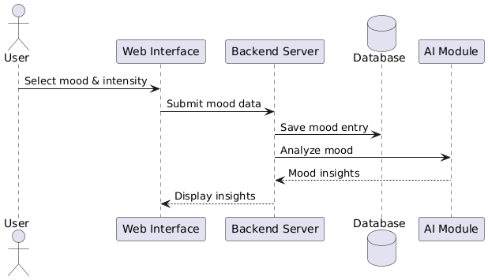
Figure 5 Sequence Diagram Mood Tracking and Analysis

4.1.3 Sequence Diagram AI Chat Interaction
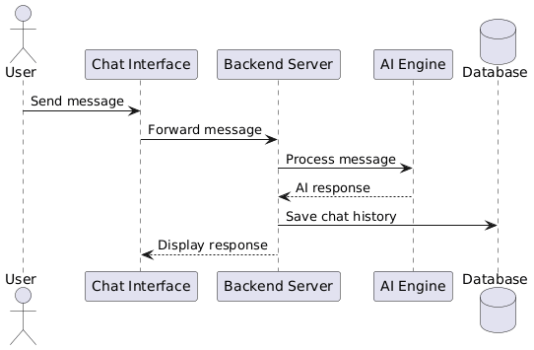
Figure 6 Sequence Diagram AI Chat Interaction

4.1.4 Sequence Diagram Appointment Booking
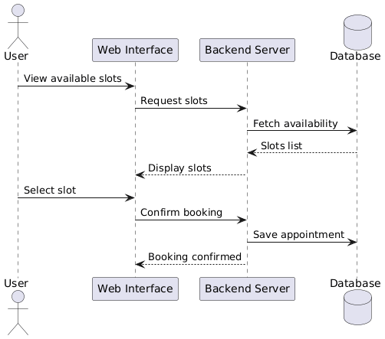
Figure 7 Sequence Diagram Appointment Booking

4.2 Data Flow Diagrams (DFD)

4.2.1 DFD level 0 (Context Diagram)
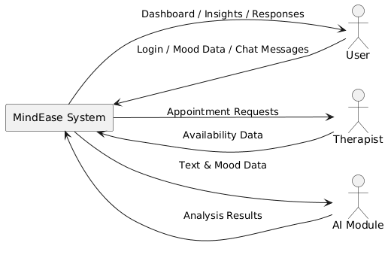
Figure 8 DFD level 0 (Context Diagram)

4.2.2 DFD level 1 User management & mood tracking
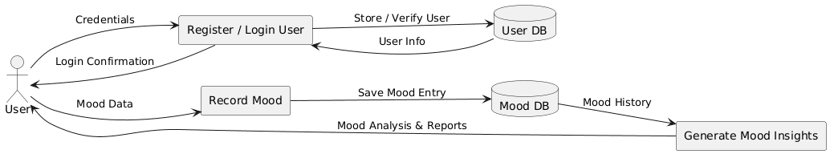
Figure 9 DFD level 1 User management & mood tracking

4.2.3 DFD level 1 AI chat & appointment booking
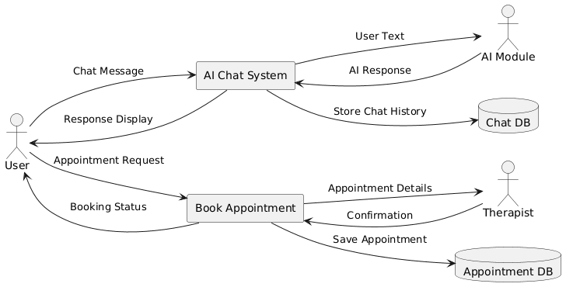
Figure 10 DFD level 1 AI chat & appointment booking

4.3 State-Transition Diagrams (STD)

4.3.1 User Account State Transition
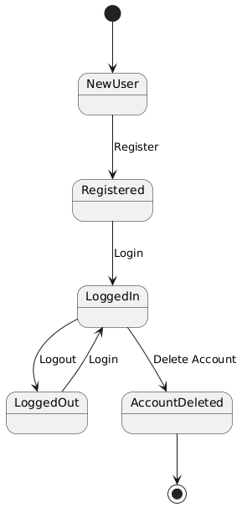
Figure 11 User Account State Transition Diagram

4.3.2 Mood Tracking State Transition
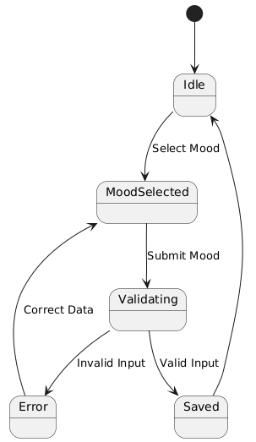
Figure 12 Mood Tracking State Transition Diagram

4.3.3 Appointment Booking State Transition
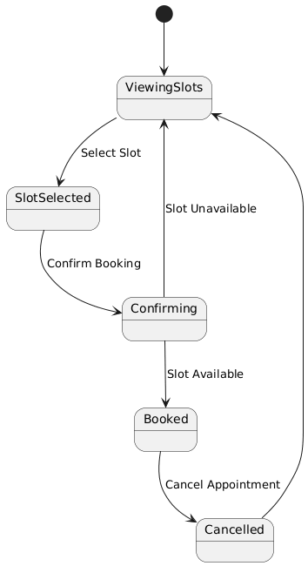
Figure 13 Appointment Booking State Transition Diagram

Chapter 5

5. Supporting Information
This section provides additional information that supports and complements the requirements defined in this Software Requirements Specification (SRS).
It includes background research related to the project domain and a data dictionary describing key data elements used within the system.

Appendix A Background Research on:
This appendix presents background research conducted to understand the domain, technologies, and challenges relevant to the Mind Ease – AI-Based Mental Health Support System.
The research helps justify design decisions and requirement definitions.

Appendix A.1 Mental Health Support Systems
Mental health support systems are digital platforms designed to assist users in managing stress, anxiety, depression, and emotional well-being.
Traditional mental health services face challenges such as limited accessibility, social stigma, and high costs. Digital platforms help overcome these barriers by providing:
- 24/7 accessibility
- Anonymity and privacy
- Self-help tools and guided support
- Early detection of mental health issues
Recent studies show that web-based mental health platforms improve user engagement and provide effective preliminary support, especially for young adults and students.

Appendix A.2 Artificial Intelligence in Mental Health
Artificial Intelligence (AI) plays a significant role in modern mental health applications.
AI techniques such as Natural Language Processing (NLP) and sentiment analysis enable systems to:
- Analyze user text to detect emotional states
- Provide personalized mental health feedback
- Predict mood patterns over time
- Assist users through AI-powered chat support
AI does not replace professional therapists but serves as a supportive tool that enhances early intervention and self-awareness.

Appendix A.3 Mood Tracking and Behavioral Analytics
Mood tracking allows users to log their daily emotional states and observe long-term behavioral patterns.
By analyzing mood data over time, systems can generate insights such as:
- Emotional trends
- Stress triggers
- Improvement or deterioration patterns
When combined with AI-based analytics, mood tracking helps users better understand their mental health and encourages proactive self-care.

Appendix A.4 – Data Privacy and Security in Mental Health Systems
Mental health data is highly sensitive and requires strong privacy and security measures.
Common challenges include unauthorized access, data misuse, and lack of transparency.
Modern systems address these concerns by:
- Encrypting sensitive data
- Implementing role-based access control
- Maintaining audit logs
Such approaches improve user trust and system reliability.

Appendix B Data Dictionary
This appendix defines key data elements used within the MindEase system.
The data dictionary ensures consistency, clarity, and shared understanding among developers, testers, and stakeholders.

Appendix B.1 User Data
Table 17 Appendix B.1 User Data
Field Name | Data Type | Description
userId | String | Unique identifier for user
name | String | Full name of user
email | String | User email address
password | String | Encrypted password
role | String | User role (user/admin/therapist)
age | Integer | User age
gender | String | User gender
createdAt | Date | Account creation date

Appendix B.2 MoodLog Data
Table 18 Appendix B.2 MoodLog Data
Field Name | Data Type | Description
moodId | String | Unique mood entry ID
userId | String | Reference to user
moodType | String | Emotional state
intensity | Integer | Mood intensity (1–10)
note | String | Optional user note
date | Date | Mood entry date

Appendix B.3 Quiz Data
Table 19 Appendix B.3 Quiz Data
Field Name | Data Type | Description
quizId | String | Unique quiz identifier
title | String | Quiz title
description | String | Quiz purpose
totalQuestions | Integer | Number of questions

Appendix B.4 QuizResult Data
Table 20 Appendix B.4 QuizResult Data
Field Name | Data Type | Description
resultId | String | Unique result ID
userId | String | Reference to user
quizId | String | Reference to quiz
score | Integer | Quiz score
interpretation | String | Result explanation
date | Date | Submission date

Appendix B.5 AIChat Data
Table 21 Appendix B.5 AIChat Data
Field Name | Data Type | Description
chatId | String | Chat session ID
userId | String | Reference to user
message | String | User message
response | String | AI-generated reply
timestamp | Date | Message time

Appendix B.6 Appointment Data
Table 22 Appendix B.6 Appointment Data
Field Name | Data Type | Description
appointmentId | String | Unique appointment ID
userId | String | Reference to user
therapistId | String | Reference to therapist
date | Date | Appointment date
time | String | Appointment time
status | String | Booked / Cancelled / Completed

